

Brecon Beacons Cycling and Mountain Biking Strategy
May 2009

Report to Brecon Beacons National Park
By Alison Caffyn
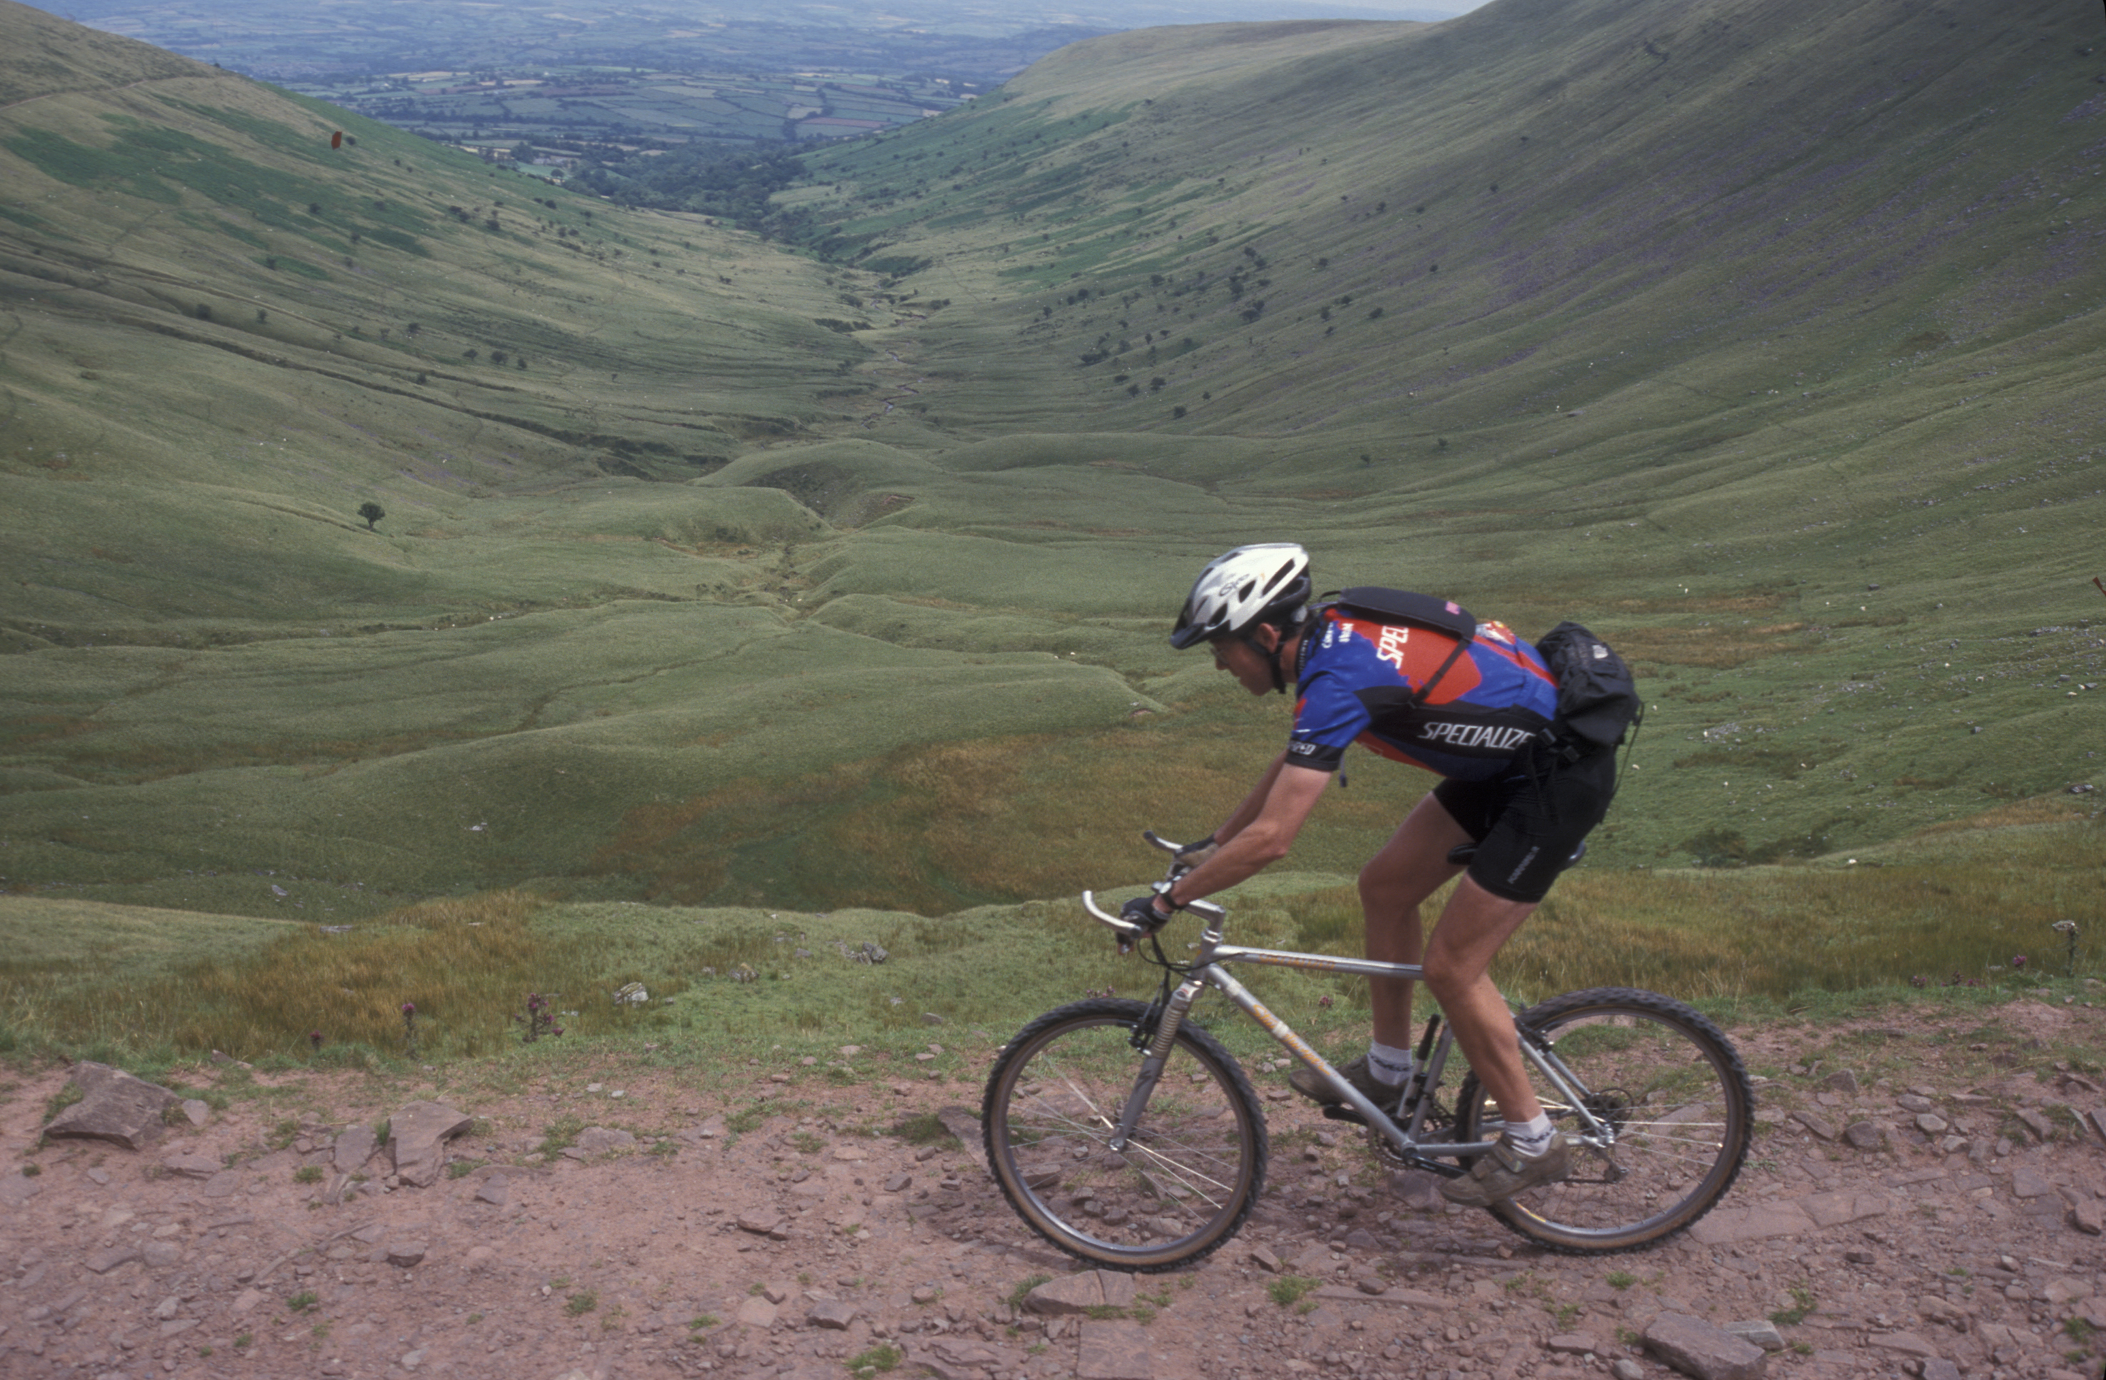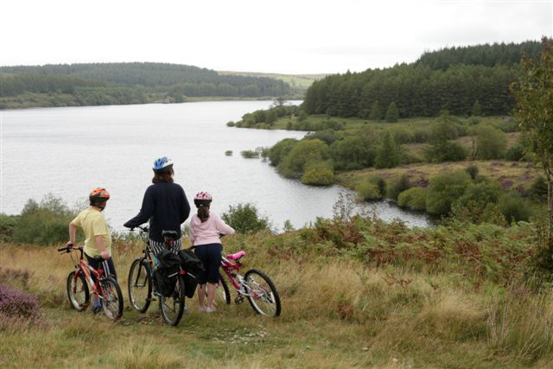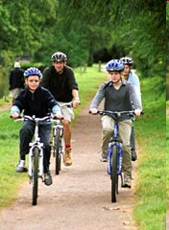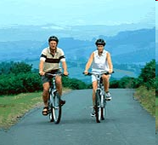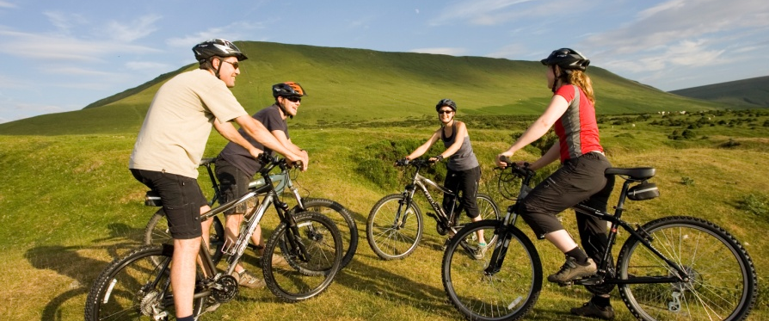

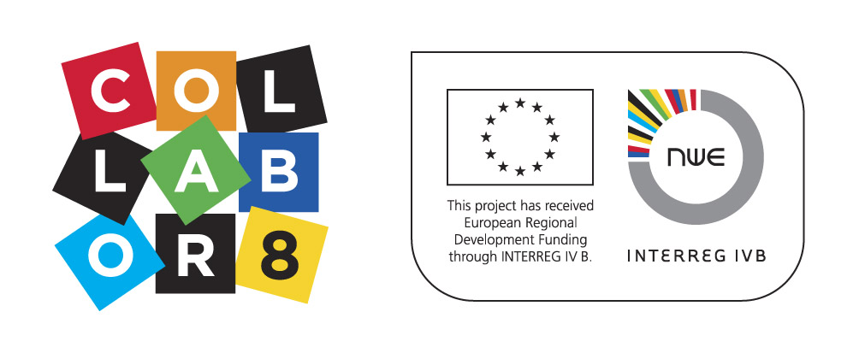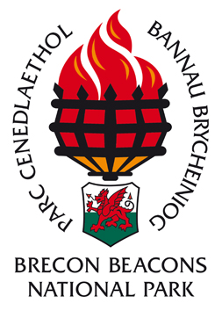

Alison Caffyn
Tourism Research Consultant
Little Bury Farm
Luston
Leominster
Herefordshire, HR6 0EB
www alisoncaffyn.co.uk

Contents
1. Executive Summary 2
2. Introduction 5
2.1 Background 5
2.2 Process and partnership 6
2.3 Strategic context and direction 6
3. Vision and objectives 10
3.1 Vision for cycling and mountain biking in the Brecon Beacons 10
3.2 Objectives of the Cycling and Mountain Biking Strategy 10
4. The cycling and mountain biking markets 11
4.1 Key trends 11
4.2 Cycling and mountain biking tourism 12
4.3 Target markets 14
5. The Brecon Beacons Cycling and Mountain Biking Offer 15
5.1 What does our area offer cyclists and mountain bikers? 15
5.2 SWOT Analysis 22
5.3 Summary of the Brecon Beacons Cycling and Mountain Biking Offer 23
6. Developing the strategy 24
6.1 Relating the offer to target markets 24
6.2 Strategic priorities 25
6.3 Priorities for the Brecon Beacons: 26
7. Action Plan 27
7.1 Introduction 27
7.2 Cycling and Mountain Biking Strategy – Action Plan 28
7.3 Key projects - Our Top Ten 36
7.4 Monitoring and evaluation 43
7.5 Taking the strategy forward 44
8. Annexes 46
8.1 Cycling and Mountain Biking Cluster - Participants 47
- Executive Summary
This Cycling and Mountain Biking Strategy supersedes the first strategy published in 2001 and has been written based on discussions with cycling and mountain biking businesses, the wider Brecon Beacons tourism industry and key local authorities and organisations active in cycling and mountain biking. It sets out priorities for further developing and promoting the Brecon Beacons as a cycling destination over the next 5-10 years. It is designed to be a working document that can be added to as progress is made and new opportunities identified.
The Vision of the Strategy is:

By 2020 the Brecon Beacons National Park will be a premier cycling and mountain biking destination with a varied network of on-road and traffic free routes and exhilarating natural trails. Many cycling and tourism businesses will work together, clustered in cycle hub towns, to provide excellent services to cyclists and mountain bikers who will return regularly to enjoy the best cycling and mountain biking breaks in the UK.

The objectives of this strategy are:
- To develop and promote cycling – making more and better opportunities to experience the Brecon Beacons by bicycle
- To develop and promote mountain biking – maintaining the Brecon Beacons as a world class mountain bike destination for natural trail riding
- To strengthen the involvement of businesses in cycling and mountain biking throughout the Brecon Beacons – offering quality services and generating more economic benefits
- To make more of cycling and mountain biking events in and around the Brecon Beacons – raising the area’s profile as a cycling destination
All within the context of developing sustainable tourism in the Brecon Beacons (economically, socially and environmentally sustainable) and improving the quality of the visitor experience through the application of sense of place concepts and initiatives. Cross reference to other programmes on quality development, the Green Tourism Business Scheme and Brecon Beacons Ambassadors will also be important.

Cycling and mountain biking in the Brecon Beacons have both strengths and weaknesses:
Strengths | Weaknesses
- Natural mountain biking in great scenery  - Identified MB routes, 5 existing hubs, easy access to information  - (Relatively) easy access from SE England/M4 corridor/Midlands  - Recognised brand – “The Brecon Beacons”  - Two established websites  - Proactive businesses and tourism groups  - Not presently over-commercialised/ developed  - Lots of bunkhouse accommodation  - Several cycling and mountain biking events | - Strong competition from forest trail centres  - Few family routes  - Beacons Bus only runs once a week on a Sunday and only into the Beacons  - Some Cyclists Welcome accommodation is not knowledgeable about cycling  - Few road routes publicised  - Some hubs more active than others  - Abergavenny and Hay not currently hubs  - NCN routes expensive and slow to develop

Cycling and mountain biking visitors will see three main offers:
- Road routes on quiet lanes through beautiful scenery – long and short circular routes
- Some traffic free routes in attractive locations inc by canals and reservoirs
- Natural mountain biking trails through scenic landscapes with varied and challenging terrain.

These need to be differentiated from forest mountain biking centres – which Wales has a strong reputation for but which are unlikely to be established in the Brecon Beacons. Also the area cannot currently boast many long distance traffic free routes – though in time this will change as more are developed and long distance routes may become a strong Brecon Beacons offer.

The top priorities are:
- Strengthening the profile of the Brecon Beacons as a quality cycling and mountain biking destination.
- Making it easier for visitors to find routes, accommodation and support services through refreshed websites, in print and through better knowledge among local businesses in the cycling hubs who can cross-promote each other. Joining things up and making it easy to buy and consume is a priority and will help retain visitors longer and encourage more repeat visits.
- Providing information for both the cyclist and mountain biking markets and both experienced and less-experienced riders.
- The main focus for more proactive promotion should be the family, casual, dabbler market
- Encouraging visitors to stay for short breaks – of at least one night and preferably longer.
- Ensure mountain bike routes are up to date, well maintained and promoted effectively
- Develop and promote more road routes for cyclists from hub towns
- Continue to support efforts to develop new traffic free routes, especially the National Cycleway Network and easy circular routes for novices and families.
- Consider developing new hub towns with routes.
- Showcasing the landscape of the Brecon Beacons in any marketing of cycling and mountain biking as this is one of the area’s main unique selling propositions.
- Integrating the green credentials of cycling as a form of sustainable tourism and linking that to other sustainable offers such as local food and drink and good environmental practices.
- Increasing and spreading the economic benefits from cycle tourism more widely.
- Ensuring that businesses targeting cyclists and mountain bikers are knowledgeable and helpful for cyclists.
- Highlighting the popular cycling and mountain biking events to raise the profile of the area for the activity.
- Explore funding opportunities to implement this strategy.
The Action Plan details a wide range of actions under six headings. The Ten Ten priority actions for immediate action are:
- Strengthen cycle hubs
- Further develop websites
- New traffic free route development
- Develop circular road routes from each hub
- Maintain and enhance mountain bike routes
- Promote the Brecon Beacons as the premier natural trail riding destination
- Strengthen collaboration between businesses
- Enhance promotion of Beacons cycling/MTB events
- Pilot new transport solutions for cyclists
- Develop mini PR Plan to support all this activity

Some of the actions can be taken forward by local authorities or outside agencies such as British Waterways, Sustrans and the Forestry Commission. However many actions require partnership working between the Brecon Beacons National Park and local businesses. Some actions can be implemented by the businesses themselves working collaboratively, perhaps with a little support from the BBNPA or other agencies such as Brecon Beacons Tourism.
It is recommended that businesses mainly work together by getting involved in their local Collabor8 cluster – particularly those based in cycle hubs - and also maintain a wider network of cycling contacts across the whole Brecon Beacons.

In Spring 2011 a brief review of the Action Plan should be undertaken to:
- Monitor progress against the targets
- Identify projects achieved which can be removed from the action plan
- Review and refresh priorities
- Set new targets for 2011/12 building on previous experience
A fuller evaluation should be undertaken after three – five years.

- Introduction
This Cycling and Mountain Biking Strategy sets out priorities for further developing and promoting the Brecon Beacons as a cycling destination over the next 5-10 years. It is designed to be a working document that can be added to as progress is made and new opportunities identified.
The purpose of the plan is to:
- Establish the Brecon Beacons as a top mountain biking and cycling destination
- Provide a framework for cycling and mountain biking development and promotion in the Brecon Beacons
- Identify the main priorities for action which can be delivered collaboratively by local businesses, local authorities and other organisations.
  - Background
The Strategy has been funded through Visit Wales and the Collabor8 Project. Collabor8 is a transnational European project which aims to contribute to the economic prosperity, sustainability and cultural identity of North West Europe with partners in Ireland, England, Netherlands and Belgium. The focus of the project is using the local landscape, sense of place and cultural heritage to help sustain the local economy and community, working with clusters of local businesses. This strategy has these values at its core – developing cycling and mountain biking as sustainable tourism products.

This is the second cycling strategy for the Brecon Beacons; the first was published in 2001. Considerable progress has been made in the eight years since it was published on some of the projects and initiatives it recommended. For example
- In 2003 the Wales Cycle Breaks pack for Brecon with five easy circular cycling routes was published. (The Brecon packs were the most popular and out-performed the rest of the cycle break location packs in Wales.)
- In 2004 the Mountain bike route pack was published featuring 16 waymarked mountain bike routes from five hub towns. These packs have sold out over five years and are currently being revised for re-publication.
- In 2005 a series of calorie counted routes were publicised to promote health messages alongside cycling activity.
- In 2007 a booklet featuring six traffic free cycling routes was published, particularly targeted at the family cycling market.
- The mtbbreconbeacons and the cyclebreconbeacons websites have grown in popularity since their launch.

Route development has, inevitably, been slower. However new routes and infrastructure include:
The Brecon Canal towpath is now accessible for cyclists from Brecon Canal Basin to Talybont on Usk.
However the condition of some other routes such as the Taff Trail may have declined over this period as little maintenance has been undertaken.
  - Process and partnership
The process of putting together this strategy started through several discussions with Brecon Beacons cycling and mountain biking partners in early 2009. They agreed to form a Collabor8 cluster in order to fund the preparation of this strategy and priority actions emerging from it. The strategy was developed building on a series of discussions with key contacts including Sustrans, WAG, Forestry Commission, Visit Wales, local authorities and the Brecon Beacons National Park Authority and pulled together through two workshops in November and December 2009. The workshops were attended by a good range of local businesses and partners involved in cycling, mountain biking and tourism. The attendees discussed the key elements of the strategy, the objectives for the Brecon Beacons as a cycling destination and identified most of the action points. All the individuals who have been involved in the process are listed in Annex 7.1.

The steps in the process can be summarised as:
- Identifying the objectives of the strategy – why the Brecon Beacons should develop and promote cycling and mountain biking and what the benefits are for the area and for visitors.
- Identifying current cycling and mountain biking visitor markets and how these may change in the future.
- Identifying what the area can offer cyclists and mountain bikers and understanding the area’s strengths and weaknesses.
- Considering how well the area meets the needs of its cycling and mountain biking visitors now and in the future and identifying opportunities to improve the offer.
- Identifying priorities and actions in order to deliver the strategic objectives over the next 5-10 years.
This Strategy follows much the same structure, considering the visitor markets and the cycling and mountain biking product on offer before identifying priorities and a full Action Plan in the final section.
The Cluster group is referred to throughout this plan as the Brecon Beacons Cycling Network – the partners may of course decide to amend this name in due course once they agree how to continue the collaboration and joint working process into the future.

  - Strategic context and direction
It is also timely to review the original cycling strategy as several national and local strategies have been produced in recent years and it is important to ensure that cycling and mountain biking in the Brecon Beacons is linked into this new policy context. This will help guide the direction and priorities of this strategy and may provide funding opportunities.
The Walking and Cycling Action Plan for Wales 2009-13 spells out the Welsh Assembly Government’s commitment to increase cycling participation. A target of increasing adult participation in recreational cycling from 5% to 10% over the period of the plan has been set. The Plan aims to:
- maximise the contribution cycling (and walking) can make to increasing tourism,
- improve cycling infrastructure including National Cycle Network routes and rights of way
- encourage the use of National Parks, forestry, countryside and coast for cycling
- improve standards of cycle parking, route signing and better cycle carriage on public transport,
- make Wales a premier destination for cycling events, and
- integrate cycling within cross cutting government policies and guidance
The Welsh Assembly Government has also recently launched its physical activity action plan which aims to promote health and well being through encouraging people to become more active, and take part in activities and sports. Although this Cycling and Mountain Biking Strategy focuses on tourism benefits there will also be many benefits for local residents of the Brecon Beacons.

At a national level the Tourism Strategy for Wales, Achieving our Potential (2006-13) sets out five strategic challenges which have been borne in mind in the drafting of this Strategy:
- Distinctive branding of destinations at all levels
- Higher quality – encouraging investment in staff and facilities to meet and exceed visitor expectations
- Easier access – both physically but also access to easy information eg on websites
- Better skills – and a motivated workforce
- Stronger partnership – of businesses and organisations to promote a sustainable and distinctive Welsh offer.

The new Visit Wales Cycling Tourism Strategy ‘Selecting the Right Gear’ was published in March 2009.
It identifies two aims:
- To encourage more people looking for a cycling holiday or break to choose Wales
- To use the availability of cycling opportunities to strengthen the visitor experience, spending and length of stay in Wales
The four key objectives of the strategy are:
  - To develop and promote cycling – make more and better opportunities to experience local destinations by bike
  - To develop and promote mountain biking – maintain a world class mountain bike product
  - To strengthen the involvement of businesses in cycling and MB – and offer quality services
  - To make more of cycling events in Wales
The strategy gives equal prominence to cycling and mountain biking and the importance of investing in better infrastructure and marketing for both. A key (and perhaps newer) element is the emphasis on engaging more businesses in cycling tourism, working with them to promote the activity and encouraging them to improve the quality of the services they offer which are an essential part of the cycling offer. Finally the focus on cycling and mountain biking events demonstrates how important the impact of events can be on raising the profile of Wales for cycling, generating coverage and attracting more participants. This Brecon Beacons strategy will follow a similar format to ‘Selecting the right gear’, so that it dovetails into the national initiatives which are getting underway.

The Brecon Beacons Sustainable Tourism Strategy gives the overall framework for the development and promotion of sustainable tourism within the National Park. This strategy supported the National Park’s successful application in 2007 for accreditation by the EUPOPARC Federation under the European Charter for Sustainable Tourism in Protected Areas. The Brecon Beacons thereby joined a network of about 40 protected landscapes across Europe which have achieved this status. The Strategy sets out a vision that the Brecon Beacons will be an exemplar of sustainable tourism in protected areas by building on a strong sense of place, indigenous cultural and natural heritage and a reputation for quality – aiming to exceed visitors’ expectations.

The other Brecon Beacons policies which this strategy must complement are the National Park Management Plan 2010-15 and Unitary Development Plan, published in March 2007. These set out the strategic objectives for outdoor access and recreation and the management and promotion of the rights of way network. The Management Plan outlines how the Park will invest in well researched, planned and co-ordinated product development based on the natural strengths of the area, backed up by research into trends, partnership working with other stakeholders and collaborative marketing. It sets out the need to manage the impacts of tourism and promote the Park as an exemplar of sustainable living including sustainable means of transport. It also mentions the aspiration to fully realise the tourism potential of the Monmouthshire and Brecon Canal including its role as a linear routeway for sustainable transport on foot, by bike and by boat.
The Development Plan identifies certain locations in the Park as ‘visitor pressure areas’ where further development or traffic are likely to cause problems. These are Talybont on Usk, Llangors Lake, Pant-y-rhiw (Llangattock Hillside) and the Llanthony Valley and particular care needs to be taken to manage the development of cycling and mountain biking in these areas. Similarly the Mynydd Du (Black Mountain) area has been identified as a ‘remote area’ which may be particularly vulnerable to increased recreational use.

The Brecon Beacons is on the periphery of several tourism regions – South East, South West and Mid Wales. It is important to link in where possible with the relevant Tourism Partnership strategies and initiatives and local authority policy documents, including transport plans, rights of way improvement plans and tourism initiatives.
In particular one very useful document produced this year is the Mountain Biking ‘Champion’ Report, written by Capital Region Tourism on behalf of Wales Tourism Partnerships. It focuses on mountain biking rather than road cycling, but its conclusions are very pertinent to this strategy. It recommends that (in competition with Scotland and other mountain biking destinations) Wales has a “real opportunity to develop its own Unique Selling Proposition by making the most of its natural terrain and compact, easy to reach geography and tapping into the larger family/casual and dabblers “mountain bike” (off-road cycling) market.”
This ‘champion’ report will be of interest to any business involved in mountain biking. It also identified that off road cycling provides a superb strategic fit with the wider Wales brand – an exciting, healthy, fun and challenging destination with beautiful landscapes and a warm welcome year round.

Other useful reports which have been consulted during the research and drafting of this strategy include:
The study into an Off-road Cycling Centre of Excellence in South Wales for the SE Wales Economic Forum, May 2009. The study recommended further developing the mountain bike centres at Afan Forest Park, Cwmcarn and Brechfa and exploring the potential for a new centre at Gethin in Merthyr Tydfil. It suggested investing to host mountain bike events at Margam Park and also recognised smaller family and leisure cycling opportunities at Garwnant, Gelliwion and Bryn Bach Country Park. These developments, should they go ahead, present both an opportunity and a threat for the Brecon Beacons – South Wales as a whole would have a raised profile for mountain biking. However if the product is focused on trail centres then the natural trail riding offer of the National park may be overlooked. The progress of these proposals should be monitored so as to link the Brecon Beacons into the Centre of Excellence concept and maximise benefits for businesses in the National Park if the developments progress.
Also useful is XC Wales – a quick and dirty strategy for developing cross country mountain biking in Wales, Pete Bursnall, November 2009. This focuses on the cross country XC mountain biking product across Wales; in which the Brecon Beacons is one of the lead destinations. It takes a practical approach to highlight the importance of rideability, navigation and support for good routes. It highlights scope to improve the furniture on routes by removing or improving gates, installing cycle cattle grids and having clear way marks which are easy to see, unambiguous and do not fade. The strategy provides lots of useful tips to bear in mind when developing new routes and endorses the concept of working with hub towns already adopted in the Brecon Beacons. Bursnall advocates a national strategy to focus on XC in Wales, which has had far less support than trail centres in the past. ‘A co-ordinated national approach to developing the product would bring great benefit in terms of funding, branding, website support, marketing, bulk purchasing etc’. He suggests that a national co-ordinator would be ideal, plus national web support with full information on routes,, events, courses, reporting, diversions, discussions, photo gallery and new route suggestions.

Given the wider context of an economic recession and ongoing pressure on public funds it is likely that the support and investment from local authorities and public sector bodies will be under severe pressure in the next few years. This Strategy aims to encourage the private sector to become more involved in the development and promotion of cycling and mountain biking. Local communities will also have an important part to play in lobbying for and supporting improved facilities in their local areas. This model of wider ownership and responsibility will hopefully enable much to be achieved even in a challenging economic climate.
- Vision and objectives
  - Vision for cycling and mountain biking in the Brecon Beacons

By 2020 the Brecon Beacons National Park will be a premier cycling and mountain biking destination with a varied network of on-road and traffic free routes and exhilarating natural trails. Many cycling and tourism businesses will work together, clustered in cycle hub towns, to provide excellent services to cyclists and mountain bikers who will return regularly to enjoy the best cycling and mountain biking breaks in the UK.

  - Objectives of the Cycling and Mountain Biking Strategy
The overall objectives of this strategy are:
- To develop and promote cycling – making more and better opportunities to experience the Brecon Beacons by bicycle
- To develop and promote mountain biking – maintaining the Brecon Beacons as a world class mountain bike destination for natural trail riding
- To strengthen the involvement of businesses in cycling and mountain biking throughout the Brecon Beacons – offering quality services and generating more economic benefits
- To make more of cycling and mountain biking events in and around the Brecon Beacons – raising the area’s profile as a cycling destination

All within context of developing sustainable tourism in the Brecon Beacons (economically, socially and environmentally sustainable) and improving the quality of the visitor experience through the application of sense of place concepts and initiatives. Cross reference to other programmes on quality development, the Green Tourism Business Scheme and Brecon Beacons Ambassadors will also be important.

- The cycling and mountain biking markets
  - Key trends
Tourism is calculated to bring £216 million to the Brecon Beacons National Park each year and supports 4,349 jobs (either directly in tourism businesses - 3,491 - or indirectly in supporting businesses). Figures for cycling and mountain biking in the area are not available but it is still very important to agree which markets are best to target - both in terms of which markets will enjoy what the Brecon Beacons has to offer and in order to maximise the economic impacts. The most up to date statistics are included in ‘Selecting the right gear’.
Key trends include:

- Road cycling is currently more popular than mountain biking but off-road cycling is growing faster.

- UK participation rates (2% of all trips) are low compared to many other countries eg Netherlands, Denmark and Germany (10-27% of trips).

- Use of the National Cycleway Network has grown each year during the 2000s by about 4% a year.

- Membership of cycling and mountain biking organisations and participation in events has grown over the last ten years.

- The proportion of women cycling and mountain biking is lower but increasing.

- About 10m people cycle at least monthly including non leisure trips

- 11% of UK adults have gone road cycling for pleasure in last 12 months (4.5m)

- There are 5.5m UK mountain bikers:
  - 1.3m enthusiasts – who ride every week
  - 1.2m regular users – who ride about 20 times a year
  - 3m occasional mountain bikers – who ride about 9 times a year
  - This adds up to about 78 million mountain biking rides a year in the UK

- Mountain bike usage at Forestry Commission mountain bike centres in Wales has increased in the last five years with some centres such as Cwmcarn, Afan Argoed and Brechfa (all in the South of Wales) doubling or trebling their numbers.

- Safety concerns about road cycling have increased and many cyclists, particularly families, are looking for off road routes

- The profile of mountain biking as a sport with the associated gear, magazines and websites has grown enormously in the last ten years.

- New bicycle design and technology (potentially including electric bikes in future) has improved performance and ease of cycling.

- Other new technologies will impact on participation including the use of sat nav or GPS for navigation, and new clothing and other equipment design.

- More people are taking part in triathlons, ‘ironman/woman’ type events and training to take part in races and events.

- Increase in UK residents taking more holidays in the UK, including more short breaks in preference to overseas trips – due to both the recession and increasing environmental concerns over flying abroad.

  - Cycling and mountain biking tourism

Cycling as a component of holidays in Wales by UK residents
 | Activity whilst on holiday |  | Main reason for trip
2006-7 | trips | spend | trips | spend
Mountain biking | 83,000 | £16.9m | 34,000 | £13.2m
Other cycling | 104,000 | £32.2m | 31,000 | £10.5m
(average for 2006 and 2007, UKTS, quoted in ‘Selecting the right gear’)

The above table shows that cycling and mountain biking where the main reason for 65,000 overnight trips annually to Wales and forms part of about 188,000 trips. While this is still way behind walking as an activity, which is the main reason for 893,000 trips, it is still quite substantial and will be focused more tightly in key locations such as the Brecon Beacons. Adding the spend figures together gives a figure in excess of £70m generated by cycle tourism in Wales annually.

Little data is available on the characteristics of the cyclists and mountain bikers but responses to Visit Wales’ 2006 campaigns give this snapshot:

Visitor characteristics
 | % male | % 25-44 | % with children in household | % ABC1 | % on visits with friends | % on visit as couple | Av length of stay
Mountain bikers | 82 | 77 | 39 | 72 | 53 | 21 | 3 days
Cyclists | 71 | Not specified but lower | 27 | 74 | 37 | 33 | 3.8 days
‘Selecting the right gear’ 2009

This suggests that on average both markets are from higher socio-economic groups, male dominated and relatively young. Most visit as part of a group or as couples. Both groups used B&Bs/guesthouses most but mountain bikers then preferred camping whereas cyclists second and third choices were hotels and self-catering/camping.

The businesses surveyed for ‘Selecting the right gear’ reported the following characteristics in their visitors:

Knowledgeable and experienced – know what they want and how to find it 68%
Less experienced and seeking guidance on where/how to go cycling in the area 33%

Have brought their own bikes with them 79%
Have hired bikes during their visit 28%

Have children under 16 with them in their group 26%
Do not have any children under 16 with them 75%

So while the majority of cyclists and mountain bikers are knowledgeable, have their own bikes with them and no children there are still quite significant proportions who need guidance, need to hire bikes and need to find family friendly routes.

The same survey found that businesses in the Brecon Beacons and Mid Wales were much more likely to say that cycling and mountain biking are important to their businesses than in other areas of Wales.
17% said it’s very important, compared with an average of 9% across Wales
66% said it provides welcome additional income, compared with 69% average
14% said it’s not particularly important, compared with 26% average
and 3% said it makes no difference to their business compared with 6% average.

The split between day and overnight visitors varies considerably depending on location. For example at the Forest MB Centres - Coed Y Brenin, which is comparatively remote from centres of population, has 67% of cyclists on holidays, whereas Afan Forest Park has 85% day trippers from home – presumably in the towns and cities of South Wales.
  - Target markets
Selecting the right gear splits the cycling and mountain biking tourism markets into eight categories

- Novice/irregular cyclists on holiday in Wales doing half day/days cycle
- Novice/irregular cyclists attracted to Wales by a gentle cycling holiday package offer
- Irregular or more regular cyclists seeking to explore a part of Wales mainly by bike (from one place or touring)
- Experienced cyclists, seeking to travel through parts of Wales on a touring holiday
- Mountain bike owners using their bikes only irregularly off-road
- Regular mountain biker, making repeat visits to one or more near to home sites
- Dedicated mountain biker seeking increasingly demanding trails
- Cycling event participants – including road races, off road endurance, downhill and elite competitions.

This is a complex set of visitor types. Four of the groups are cyclists, three are mountain bikers (package holiday offers are not seen as important for mountain bikers, although there are some companies offering this experience in the Brecon Beacons) and the final group are motivated by events and competitions. They are categorised based on their level of experience and regularity of participation.

The next section analyses the cycling and mountain biking offer in the Brecon Beacons and we will then relate this to the target market categories in order to develop the overall strategy.

- The Brecon Beacons Cycling and Mountain Biking Offer
  - What does our area offer cyclists and mountain bikers?
The network of road, traffic free and mountain biking routes are the fundamental elements in the tourism offer to cyclists and mountain bikers.
National cycle routes
Two National Cycleway Network (NCN) routes currently cross through the Brecon Beacons see map below.
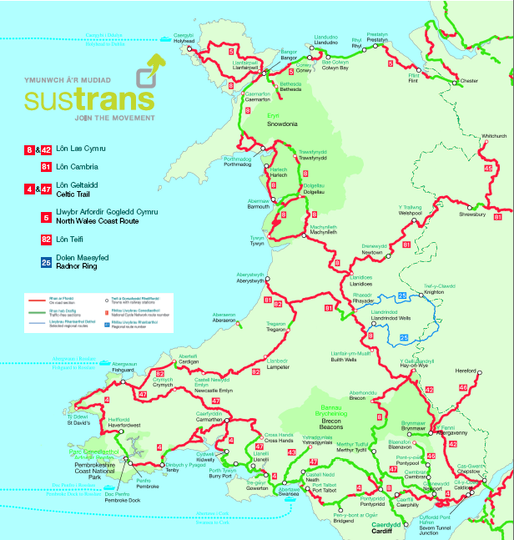
The Taff Trail (NCN 8) runs south from Brecon, past the Talybont Reservoir and on to Merthyr Tydfil and Cardiff. The full route is 55 miles (88km) long one way. Much of the route is traffic free – the green sections on the map.
NCN 8 also continues north as Lon Las Cymru from Brecon to Hay on Wye and then north west right across Wales to Holyhead.
NCN 42 is an alternative stretch of Lon Las Cymru south from Hay to Abergavenny via the Llanthony Valley and on to Chepstow on the Bristol Channel.
NCN 46 links Brynmawr and Abergavenny in the South East of the National Park on a traffic free route.
Work is ongoing on the Heads of the Valley traffic free route which will link Merthyr Tydfil and Brynmawr to connect up the other routes in the Beacons into a full circular NCN route.
The western half of the National Park has no NCN routes. Route 43 north from Swansea has just reached the edge of the National Park at Coelbren near Ystradgynlais. The hope is that it will follow the disused railway line up the Upper Swansea Valley and past Crai reservoir to Sennybridge/Libanus and Brecon.
Sustrans has long term aims to develop a full network of traffic free routes across South Wales. The map below shows in blue the routes which it will aim to develop over the next 5-15 years. It is clear that once these routes exist a wide range of long circular cycle rides will be possible, around and through the National Park. There could be considerable potential to market longer cycling breaks and long distance rides. However the full network is many years off.
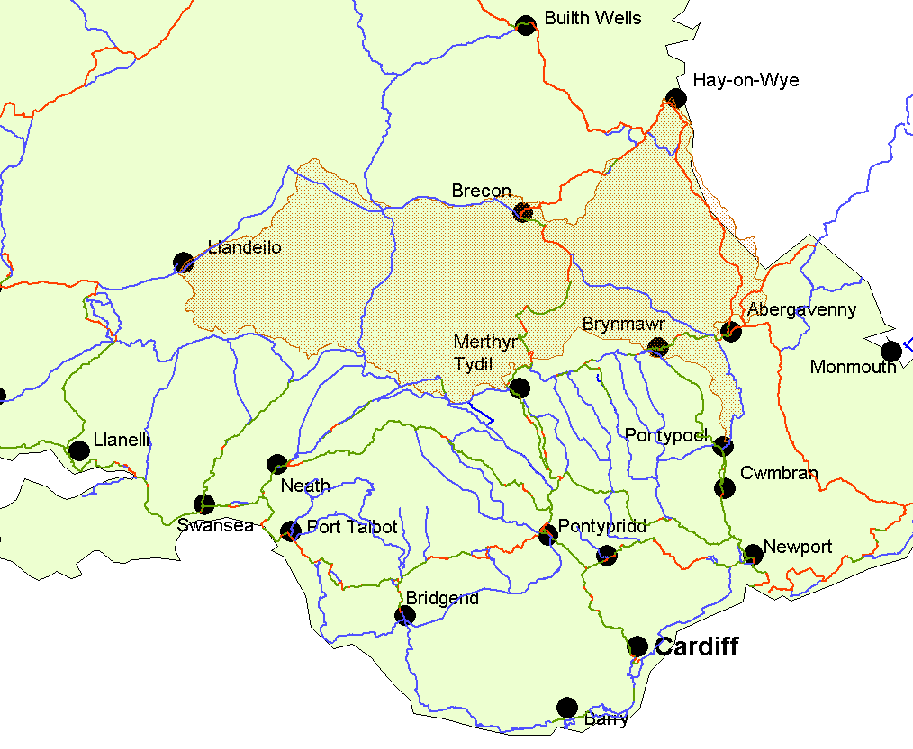
It may be possible to develop and promote other road based routes, along suitable roads. For example an Offa’s Dyke cycle route is proposed which would run down the eastern flank of the National Park along the border with England. An east-west route across the north of the Park has also been discussed as an aspiration.
Developing better cycling routes around towns is a priority for local authorities such as Powys County Council and Sustrans through the Sustainable Town Projects – aiming to improve cycling routes for residents. This also links to the Safer Routes to Schools initiative. Brecon might be a strong candidate for such an approach in future.
Wales Cycle Breaks – pack of routes from Brecon
The pack includes maps and descriptions of five circular routes from Brecon on quiet roads and some short off road sections. The routes vary between 6 miles and 52 miles long. The pack includes maps which can be taken out to use as one is riding, plus details on transport and sources of information. Packs also contain listings of cycle friendly accommodation, cycle hire and cycle shops.
The packs have only sold moderately – the concept of packaging cycle breaks in this format has yet to be proven. However the pack demonstrates how a series of circular cycle routes from a town can be packaged so that people wanting to do just one ride may choose which distance and terrain appeals most.
On Road Routes
Few other on road routes are currently promoted. There is scope to plan out circular routes from each town – as with Brecon above – or have routes linking each town. Ideally these need to use quiet roads wherever possible.
Traffic free routes
Six routes are currently promoted at locations across the National Park:
Route | Location | Distance
Usk Reservoir Cycle Trail | Glasfynydd Forest | 6 miles
Garwnant Forest Trails | Garwnant near Merthyr | 5 miles or 11 miles
Brecon to Brynich Lock  - see map below | Monmouthshire and Brecon Canal | 2.5 miles each way  Now open to Talybont = 6 miles each way
Talybont Reservoir to Torpantau – see map below | Talybont | 5.5 miles each way
Llanfoist to Clydach Gorge | Abergavenny | 5 miles each way
Goytre Wharf to Llanfoist | Between Ponypool and Abergavenny | 5 miles each way

Three routes are along stretches of the Monmouthsire and Brecon Canal – which may in due course be opened up along its entire length. Two other routes are round or alongside a reservoir. There is a lack of traffic free routes in the north east and central-south west areas of the National Park.
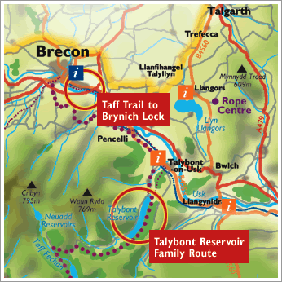
Future options are still being investigated but will take time to realise. Powys County Council plan a feasibility study into a disused railway line route from Hay to Glasbury and hope to also look at the disused railway line from Sennybridge to Brecon. This may require a new bridge across the Honddu at some point.

MB ‘centres’ or hubs and routes
Five towns were selected to be the first mountain biking ‘centres’ or hubs for the development of the first pack of Brecon Beacons mountain biking routes. These are:
- Brecon
- Crickhowell
- Sennybridge
- Talgarth
- Talybont
The hubs are all close to off-road mountain biking routes and have facilities including parking, refreshments, toilets, cycle friendly accommodation and outdoor equipment retailers.

Sixteen routes were researched and written up to be published in the first pack of mountain biking routes in 2004. The routes are graded using the standard mountain biking system:
Yellow - a fairly flat route of less than 8km
Green - moderate route of up 8-20km
Blue - moderately steep route of 8-25km
Red – steep routes 30-40km
Black – extreme terrain over 50km
Most are off road but include short sections along quiet lanes where necessary. They are distributed as follows:
 | Yellow | Green | Blue | Red | Black
Brecon | 1 |  | 1 | 1
Crickhowell |  |  | 1 | 1
Sennybridge |  | 2 | 1 | 1
Talgarth |  | 1 |  | 2 | 1
Talybont |  | 1 | 1 | 1

Each route has an independent route map and description which can be taken on the trip.
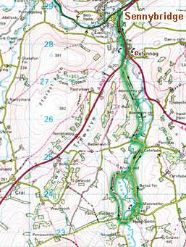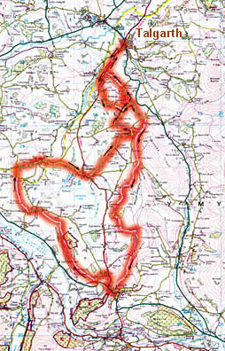
All are listed on the mtbbreconneacons website along with details of support service businesses and cycle welcome businesses. The route maps are printable only at small scale from the website in order to encourage people to buy the full packs. The sale of the packs has funded the review and publication of the second version of the pack which is due for publication in 2010. A proportion of the sale of the packs is devoted to route maintenance,
There are some criticisms of specific routes or stretches of route that are very muddy in bad weather, badly rutted or have lots of gates which are difficult to open from a bike. Maintenance is certainly a concern and resources relatively limited.
Also the cycle facilities in each town vary – not all have good cycle parking or information about cycling options in appropriate locations.
Events
There are several cycling and mountain biking races and events held in or near the National Park:
The Verenti Dragon Ride – in early June from Bridgend north to Hirwaun, Sennybridge and down the Upper Swansea Valley to Glynneath, Neath and back to Bridgend. 40, 130 or 190km non-competitive cyclo-sportive race – only the longest loop takes in the Brecon Beacons. (www.verentidragonride.com)
Abergavenny Festival of Cycling - over a week in late June includes two day iron mountain sportif race a 25 mile time trial, accompanied rides all week, an open criterium and road race championships (www.abergavennyfestivalofcycling.co.uk)
Slick and Knobbly Cycling Festival mid July – a weekend based event including ‘dirt crit’ racing for young riders and a mountain bike endurance challenge. It shared a campsite on the GlanUsk Estate Crickhowell with the Devil Ride sportive road race which cut across the north of the National Park. (www.sip-events.co.uk/slick-knobbly and www.cyclosportives.co.uk )
Tour of the Black Mountains – last weekend of July - a road race with 56, 96 and 117 mile routes through the Brecon Beacons starting and finishing in Abergavenny (www.touroftheblackmountains.com)
The Brecon Beast a 60 or 100km mountain biking race in mid September (www.breconbeast.co.uk )
Cycling and mountain biking businesses
There is a good network of cycling and mountain biking businesses with a range of offers. Some are outdoor activity providers who offer cycling/mountain biking as well. Some provide cycling and mountain biking trips and holidays – guided or self-guided. Several offer bike hire and repair services. Some are purely retail businesses. Most contributed to this strategy and are listed in Annex 1.
Businesses welcoming cyclists
There are approximately 70 accommodation businesses in the National Park with the VisitBritain Cyclists Welcome accreditation. This means they have satisfied a checklist of cycling related criteria when being inspected for their standard accommodation grading. The checklist includes being able to provide pack lunches, bicycle repair kits, bicycle storage and kit drying facilities. Visit Wales are reviewing these criteria as part of the VW cycle tourism strategy as there is some feeling that they are not proactive enough. Anecdotally, owners of some of the cyclists welcome accommodation in the Brecon Beacons do not know much about cycling routes and facilities and simply meet the bare minimum of criteria. There are of course many bunkhouses around the National Park, most of which have good facilities for cyclists. The Youth Hostel Association are also currently improving their facilities for cyclists.
There are also many cafes and pubs which also welcome cyclists although few have recognition of this through an official scheme. Examples include The Bridge Cafe, Brecon, Talybont Stores (where the new XCafe offers a bikers breakfast), and The Tower Hotel, Talgarth has a room dedicated to mountain bikers with maps on the wall.
The key aspects of the current cycling and mountain biking offer are summarised in the SWOT Analysis below. This also identifies many of the opportunities that have been identified during discussions and the possible threats which could hinder progress.

  - SWOT Analysis
Strengths | Weaknesses
- Scenery and landscape  - “Real” mountain biking – natural and wilderness trails  - Cycling as part of an outdoor-focussed holiday  - Weekend “escapes”  - Quality of available accommodation/other tourism services  - Identified MB routes, 5 existing hubs, easy access to information  - (Relatively) easy access from SE England/M4 corridor/Midlands  - Recognised brand – “The Brecon Beacons”  - Two established websites  - Proactive businesses and tourism groups  - Diverse landscapes – range of attractions  - Not presently over-commercialised/ developed  - Lots of bunkhouse accommodation  - Close to Swansea and the Gower (high profile visitor destinations)  - Several cycling and mountain biking events | - Little trail maintenance undertaken in some locations  - Strong competition from forest trail centres  - Lack of family routes  - Beacons Bus only runs once a week on a Sunday and only into the Beacons  - Some Cyclists Welcome accommodation is not knowledgeable about routes and support  - No local events held in Bike week each year  - Few road routes publicised  - Some cycle centres/hubs more active than others  - Abergavenny and Hay not recognised as hubs currently  - NCN routes expensive and slow to develop  - Many events are oversubscribed so don’t promote themselves much
Opportunities | Threats
- Upgrading websites and promotional information  - Raising the profile of what the Brecon Beacons has to offer  - Visit Wales strategy implementation/funding  - Creating more traffic free routes  - Promoting more natural trail riding  - More cycle aware businesses who know about routes, offer deals and packages and have good links  - Attracting and supporting cycling events/festivals  - A strengthened Cyclists Welcome scheme  - Collabor8 support for networks/clusters of businesses – eg promotion, marketing, training  - New routes– road, off road and mountain biking – especially Sustrans extension of NCN routes  - New town hubs  - Improve facilities at key points eg bike racks, parking, cafes, signing  - Promote bike hire for people already on holiday  - Better provision for bikes on trains and buses  - Incorporate cycling into more local events and/or better links between events and accommodation/pubs etc  - Cross promotion between businesses  - Form a group of keen businesses to work together to promote cycling and mountain biking in the National Park  - Regional Transport Plan funding | - Bureaucracy across boundaries  - Competitor facilities and destinations moving swifter to improve  - Lack of critical mass  - Recession – including further loss of businesses eg pubs  - Reduced public sector  - Limited lottery funding  - Lack of resources for rights of way network  - Lack of will or capacity to implement improvements  - Reduction in resources at Forestry Commission  - Trail Centres dominating the market to the detriment of natural trail riding  - Visit Wales not undertaking standalone cycling campaigns in next few years

  - Summary of the Brecon Beacons Cycling and Mountain Biking Offer
Assessing the offer from the perspective of potential cycling and mountain biking visitors they will see three main offers:
- Road routes on quiet lanes through beautiful scenery – long and short circular routes
- Some traffic free routes in attractive locations inc by canals and reservoirs
- Natural mountain biking trails through scenic landscapes with varied and challenging terrain.
These need to be differentiated from forest mountain biking centres – which Wales has a strong reputation for but which are unlikely to be established in the Brecon Beacons.
Also the area cannot currently boast many long distance traffic free routes – though in time this will change as more are developed and long distance routes may become a strong Brecon Beacons offer.
Competitor destinations
The Visit Wales strategy Selecting the Right Gear includes a thorough analysis of competitor cycling and mountain biking destinations for Wales.
In terms of mountain biking, competitor destinations are largely those developing more trail centres. These include:
- Kielder Water, Northumberland
- Cannock Chase, Staffordshire
- South West England – where five new hub sites are proposed, including some close to the M4 corridor.
- Scottish Borders – where the 7stanes have a strong reputation and 400,000 visits a year.

Cross country or natural mountain biking competitor destinations include the Peak District, lake District and Snowdonia. Other areas where cross-country mountain biking is being developed include Northern Ireland, Ireland and Austria.
Similarly leisure cycling development is strong in Northern Ireland, Ireland and Germany – more details are available in the Appendix to Selecting the Right Gear.
Other lessons could be learned from countries such as Belgium and the Netherlands with which the Brecon Beacons is working on the Collabor8 transnational Interreg IVB NWE programme.
- Developing the strategy
  - Relating the offer to target markets
Section 2 outlined the vision and objectives of the strategy. Section 3 discussed the cycling and mountain biking markets and section 4 has identified the area’s offer, its strengths, weaknesses and opportunities to address these to better meet visitor expectations. Here we pull these elements together to consider how the current offer matches up to the needs and expectations of each visitor type, particularly as expectations continue to increase over time.
In the table below the three main offers of the Brecon Beacons identified in section 4 are ranked for each of the target markets identified in selecting the right gear - the Wales cycling tourism strategy, with 1 most important to 3 least important for each market group. No rank is given if the market will not use that offer at all.
 | Quiet road routes | Traffic free routes | Scenic natural trails
- Novice/irregular cyclists on holiday in Wales doing half day/days cycle | 2 | 1 | -
- Novice/irregular cyclists attracted to Wales by a gentle cycling holiday package | 1 | 2 | -
- Irregular or more regular cyclists seeking to explore a part of Wales mainly by bike (from one place or touring) | 1 | 2 | -
- Experienced cyclists, seeking to travel through parts of Wales on a touring holiday | 1 | 2 | -
- Mountain bike owners using their bikes only irregularly off-road | 3 | 1 | 1
- Regular mountain biker, making repeat visits to one or more near to home sites | - | - | 1
- Dedicated mountain biker seeking increasingly demanding trails | - | - | 1
- Cycling or MB event participants | Road races | Mass participation events | MB races/ enduro events

It can be seen that novice or irregular cyclists and mountain bikers will tend to prefer traffic free routes. These will be perceived as safe and not too long or strenuous. Ideally these could be just half a days riding, perhaps interspersed with interesting sites or stopping points to break the cycling into shorter chunks of time.
All other cyclists will enjoy road routes – and will want a choice of length of route and amount of climb depending on their fitness and time available. Road routes can be linear or circular. Circular routes are best for casual cyclists, those that have arrived by car and for encouraging longer stays in local accommodation. However linear routes are possible if there is convenient public transport or shuttle buses to return one to the start or if people are doing multi day rides across country.
Mountain bikers will enjoy the scenic natural trails – again the length and severity of the route they require will depend on experience, fitness, weather conditions and time available. Most mountain bike routes are circular although two day routes and long distance routes are possible.

This exercise helps identify what the priorities should be for developing the cycling and mountain biking offer and how the area should be promoted as a cycling destination.
  - Strategic priorities
There are a range of actions which have been identified in Selecting the Right Gear the Wales cycling tourism strategy which are particularly relevant for the Brecon Beacons including:
- Strengthen the presentation of opportunities for natural trail riding
- Trying to attract competitive cycling events of significance to Wales
- Encouraging more tourism enterprises to promote cycling actively to their visitors
- Strengthen and sharpen the Visit Wales cyclists welcome scheme.

The Mountain biking champion report recommends that Wales differentiate itself from Scotland’s mountain bike tourism product which “is aimed heavily at the niche expert/extreme market – the stereotypical ‘adrenaline junkie’.” It suggests Wales should target the much larger “family/casual and dabbler “mountain bike” market (remembering this term includes all off-road cycling) due to ease of accessibility… and it has more novice/family friendly trails and less extreme weather”. It identifies that ‘natural’ mountain biking is attractive to the casual rider who is interested in culture and scenery along the way not just the thrills and spills of downhill and forest centre trails. The developing network of NCN routes is also a strength.
Following this logic the report suggests that there is little point marketing to expert mountain bikers who do their own research and rely heavily on recommendations from other riders. Dedicated riders will head for the trails they want to ride almost regardless of the distance or support facilities. In contrast, the “family/casual and dabbler market” looking for an active weekend away are more likely to be influenced by destination marketing as their knowledge is more limited.
“Wales has a real opportunity to develop its own USP by making the most of its natural terrain and compact, easy to reach geography and tapping into the larger family/casual and dabblers “mountain bike” (off-road cycling) market. This is not to say the expert/extreme “mountain bikers” do not and will not visit Wales, as we know they do and will through Wales’ word of mouth reputation. However, the current marketing and product development should focus more on the casual/family market as it’s a more economically viable target market who can be engaged with through solid, quantifiable marketing techniques.”
Building on these recommendations and the earlier sections of this strategy the following set of priorities has been identified.
  - Priorities for the Brecon Beacons:
- Strengthening the profile of the Brecon Beacons overall as a quality cycling and mountain biking destination.
- Making it easier for visitors to find routes, accommodation and support services such as repairs and transport through refreshed websites, in print and through better knowledge among local businesses in the cycling hubs who can cross-promote each other. Joining things up and making it easy to buy and consume is a priority and will help retain visitors longer and encourage more repeat visits.
- Providing information for both the cyclist and mountain biking markets and both experienced and less-experienced riders (improving riders may be better than absolute beginners due to the limited numbers of traffic free routes).
- The main focus for more proactive promotion should be the family, casual, dabbler market – following the advice quoted above.
- Encouraging visitors to stay for short breaks – of at least one night and preferably longer – making it easy and attractive to stay, not drive straight home.
- Ensure mountain bike routes are up to date, well maintained and promoted effectively
- Develop and promote more road routes for cyclists from the main hub towns
- Continue to support efforts to develop new traffic free routes, especially the National Cycleway Network and easy circular routes for novices and families.
- Consider developing new hub towns and integrating them into the information on promoted road and mountain biking route
- Showcasing the landscape of the Brecon Beacons in any marketing of cycling and mountain biking as this is one of the area’s main unique selling propositions
- Integrating the green credentials of cycling as a form of sustainable tourism and linking that to other sustainable offers such as local food and drink and businesses with good environmental practices.
- Increasing and spreading the economic benefits from cycle tourism more widely – particularly by strengthening the links to a wider range of local businesses and involving them more directly in developing and promoting cycling and mountain biking.
- Ensuring that businesses targeting cyclists and mountain bikers are knowledgeable and helpful for cyclists – through a strengthened national cyclists welcome scheme or local initiatives
- Highlighting the popular cycling and mountain biking events to raise the profile of the area for the activity.
- Explore funding opportunities to implement this strategy through mechanisms such as Collabor8 support for networks/clusters of businesses and other sources for infrastructure improvements or marketing.
A number of actions have been identified to address these priorities which are detailed in the next section.
- Action Plan
  - Introduction
This section builds on previous sections by putting the strategy into practice and developing an action plan to achieve the vision and objectives. It lists all the ideas and proposals suggested during the process or identified by the consultant, under the priority headings. The table summarises a wide range of potential actions and begins to identify which are most important and which can be delivered sooner or need to be worked on for longer. The columns begin to identify who needs to be involved and where any funding required may come from. With all the actions the crucial factor is what organisation is willing to take the lead and drive things forward. There are also actions which the private sector can lead on either collectively or within their own business.
This action plan will become a working document to guide the implementation and delivery of the strategy. It will need to be added to and amended as more information and detail becomes available. It will need to be reviewed annually to tick off actions completed and review the progress towards others. New actions and ideas can be added as they arise.
The tabular plan is followed by more detailed descriptions of the top priority actions.
Key to Action Plan
Priority/ importance | Timescale | Lead/delivery
VH - Very High | QW - Quick Win - 6-12 months | 1 - We can deliver locally i.e. BBCN
H - High | S - Short Term - 1-2 years | 2 - We can deliver with partners/outside support
M - Medium | M - Medium Term - 2-5 years | 3 - Business investment opportunity
L - Low | L - Long Term - over 5 years | 4 - Needs outside lead
Priorities need to be reviewed and amended by the Brecon Beacons Cycling Network periodically.

Key to acronyms
BBCN – Brecon Beacons Cycling Network
BBT – Brecon Beacons Tourism
BBNPA – Brecon Beacons National Park Authority
BW - British Waterways
CRT – Capital Region Tourism
PCC – Powys County Council
TPMW – Tourism Partnership Mid Wales
VW – Visit Wales
WAG – Welsh Assembly Government

  - Cycling and Mountain Biking Strategy – Action Plan
Actions shaded in blue are high priority and are described in more detail in section 6.3 below.
The Lead column includes a number (see key above) to indicate how delivery of the action could be carried out
No. | Action | Prior-ity | Time-scale | Lead | Details
1 | Development actions for both cycling and mountain biking
1.1 | Strengthen existing Hubs by co-ordinating information better on routes and services - show the varied options for road, easy off-road and MB routes for each hub all on the same map – eg on website and at car parks - and map the bike services, support and hours etc for each hub. Encourage more businesses to link to Sustrans GIS mapping facility for routes and facilities in their area. See also 5.2 – more business involvement in hubs. | VH | S | 2
1.2 | Consult businesses and discuss developing new hubs - particularly Abergavenny where there are several keen businesses and Llandovery in order to have a hub on the western side of the park– research and map MB and road routes from each, including routes from rail stations (both Cardiff and Heart of Wales lines). Also possibly Hay on Wye. | H | M | 2
1.3 | Each hub to discuss parking issues for cyclists/MBers arriving by car. Is there sufficient public parking and if not what other options exist eg pubs, cafes or attractions allowing parking perhaps in return for using the facility on their return. Or use of village hall car parks. | H (for some) | S-M | 1 and liaise with cycling officer | PCC
1.4 | Pilot new transport solutions for cyclists using minibus and trailer eg Friday afternoon pick ups from Cardiff | H | S | 2
1.5 | Lobby bus companies inc Beacons Bus – to allow more bikes on buses and more useful bus routes – eg bus south from Brecon in morning so can ride back | H | L | 1 and 4
1.6 | Lobby train companies to improve facilities for bikes – carry larger numbers, more flexible booking, joint ticketing eg arrive on one line and back on another | H | L | 1 and 4
1.7 | Encourage creativity linked to the cycling offer such as interpretation of routes eg audio guides, themed routes or use of GPS handsets and GIS mapping. | M | M | 2 | Sustrans
1.8 | Provide secure storage options (in each hub) or at certain businesses which promote the fact, to enable people to park while they eat/drink/shop/fetch their car. Potential for this at leisure centres, visitor attractions, pubs, cafes, village halls. (Note PCC are working with developers on new parking standards currently) | L | M-L | 3
2 | Marketing actions for both cycling and mountain biking
2.1 | Further develop Brecon Beacons cycling and mtb Websites – review and refresh the two websites, add more photos, additional pages (eg more on train and bus links, plus list which taxi firms can take bikes and typical costs for popular routes). | VH | QW | 2
2.2 | Review website (after Summer 2010 upgrade). Develop further features to go on NP website or set up a more commercial partner website run by cycling cluster group of businesses with the additional features. To include film clips of routes filmed by helmet cams. Blogs/recommendations by local businesses – taking it in turn to update. Special offers, training sessions etc. User generated content, pictures and recommendations. Facebook page, photos on Google Earth, other new media features. | H | S | 2 | August 2010
2.3 | Develop mini PR Plan – plan stories for key dates in 2010/11, compile and contact more media contacts, identify businesses happy to host journalists | VH | S | 2
2.4 | Monitor media coverage eg with Google alerts and maximise media impact by emailing web links to local businesses and previous customers and copying articles to encourage visitors to try cycling. | H | ongoing | 1
2.5 | Ensure Brecon Beacons routes are featured prominently on Wales and UK websites alongside similar types of routes – eg promote a choice of off road family cycle routes in mid Wales with Beacons routes alongside routes from other areas all on Visit Wales sites. Post routes on popular new Wales sites such as 1000 Things. | M | S | 2
2.6 | Encourage and support cycling holiday operators to build the volume of cycling holidays – developing better websites and infrastructure | M | S | 2
2.7 | More market research into those who mountain bike and cycle here or not eg through web questionnaire, or questionnaire via businesses, or at events. To help monitor cyclists and mountain bikers’ views, opinions and visitor characteristics. Also an opportunity to capture contact details and compile mailing lists. | M | S-M | 2
2.8 | Promote cycling options and bike hire at stations | L | L
2.9 | More businesses to link to information for promote train and bus options to visitors before they arrive – can arrange tickets and then offer bike hire while here | L | M
2.10 | Link to the Olympics – in run up and afterwards in vacuum post Olympics – Olympic cyclist training, encouraging additional local participation, promote events which link into Olympic dates etc. | L | S-M
3 | Specific cycling actions
3.1 | Work with Sustrans and local authorities to develop strategic new NCN routes especially the Heads of the Valley route (46) and route 43 up the Upper Swansea Valley. | VH | M | 4 | Sustrans
3.2 | Work with British Waterways to further extend the Brecon canal cycle route with the eventual goal of a continuous off road route from Brecon to Pontypool. | VH | M-L | 4 | BW
3.3 | Develop road cycle routes for each hub of varying lengths for inclusion in a new pack of routes and/or downloadable from the cycling website | VH | S | 2
3.4 | Develop longer circular road route options for experts eg based on road race routes (eg Tour of the Black Mountains 56, 96 and 113 mile routes or top section of Kiron Dragon ride) or as multi day routes for slower cyclists (like Radnor Ring). | H | S | 2
3.5 | Develop an east-west cross-Beacons road cycle route (ideally starting and finishing at towns with rail stations). Potential for north and south routes – Hay-Llandovery and Abergavenny to Llandeilo in the longer term. | H | S | 2
3.6 | Work with local authorities (especially cycling officers) and link into regional transport plans, cycling strategies, community cycling plans and safe routes to schools routes – to support and promote routes which will benefit visitors as well as local residents for utility journeys as well as for recreation. | H | M | 2
3.7 | Lobby local authorities for better maintenance of roads, removal of potholes etc and more cycle routes sections on main roads. | H | L | 1 and 4
3.8 | Support the promotion of an Offa’s Dyke cycle route (road route) from Chepstow to Prestatyn. | M | S | 4
3.9 | Create more easy off road/family routes eg lobby the Forestry Commission to identify potential new routes. Promote existing options around the edge of the National Park, eg the Epynt Way and Crychan Forest or short links between towns/villages eg Talgarth to Glasbury | M | M-L | 3
3.10 | Investigate new niches – eg as a good venue for stamina, triathlon and etape training and develop targeted products/packages and offers. | M | M | 2
3.11 | Work with other National Parks/Visit Wales to map a Three Parks Ride connecting and through the three national parks in Wales - potential for a special event promotional PR etc | L |  | 4
4 | Specific mountain biking actions
4.1 | Continue to review the promoted mountain bike routes and ensure all are good quality and in good condition | VH | ongoing | 1
4.2 | Highlight food, attractions and support/repair facilities on the new MB route maps/website | VH | QW | 1
4.3 | Ensure waymarked routes are well signed and checked – encourage reporting of problems via contacts or website to NP rights of way team | VH | S | 2
4.4 | Promote the Brecon Beacons as THE best natural trail riding destination in Wales/the UK | VH | S | 2
4.5 | Encourage more mountain bikers to stay overnight – feature more accommodation, packages and offers on the website and through bike hire/shops etc | H | S | 1
4.6 | Liaise with Forestry Commission over routes on their land especially re diversions for forestry operations to ensure warnings can be posted on websites – plus influence FC to ensure diversions use good routes, well signed and for minimum periods. | H | S-M | 2
4.7 | Promote more MB skills training and beginner rides eg via the website. | H | ongoing | 1
4.8 | Identify several two day routes to encourage more MBers to stay overnight | M | QW | 2
4.9 | Investigate opportunities to use/promote GPS to mountain bikers – feature specific routes on GPS systems etc. | M | S | 2
4.10 | Liaise with NP rights of way team and Forestry Commission to identify other ways to help upgrade poor sections – eg volunteer holidays or work parties. | M | M | 2
4.11 | Launch a new route each year (or a rebranded/amended one) to ensure there is always something new to attract people who have done most other routes. (or 2-3 new ones every 2-3 years) | M | M | 2
4.12 | Pursue opportunities to open new stretches of traffic free easy routes – extensions to existing routes, disused railways, other new routes. | M | M | 2
4.13 | Support the creation of a cycle route from Merthyr to Garwnant Forest trails | M | M | 3
4.14 | Investigate funding opportunities to implement the previously completed feasibility study into upgrading the Taff Trail (west) walkers route to mountain bike standards. | M | L | 3
4.15 | Develop an E-W MB route across the Brecon Beacons | M | L | 2
4.16 | Link into discussions about developing a new trans Wales MB route and influence it to include the Brecon Beacons on the route. (One option is the Sarn Helen North to South Wales route.) | M | L | 4
5 | Business involvement
5.1 | Strengthen links between cycling businesses and other outdoor activity providers to cross-promote activities and develop multi activity packages – for less dedicated cyclists. | VH | QW | 1
5.2 | Hub development – engage more businesses and encourage more cross selling of cycling and accommodation, develop specific packages or offers | VH | QW | 1
5.3 | Cycle businesses to host promotional or familiarisation trips for local accommodation and other businesses within hubs | H | QW | 1
5.4 | Need to market and explain current Cyclists Welcome scheme – liaise with Visit Wales to check results of review and any changes implemented. Communicate this to businesses and visitors if/when it does change. | H | S | 4 and 2
5.5 | Cycling and mountain biking packages – encourage and support development of packages, discounts, special offers and easy booking targeted at the non specialist cyclists and mountain bikers | H | M | 1
5.6 | Check websites/leaflets for attractions around the National Park and encourage them to include information for cyclists on facilities, routes etc. and to provide cycle racks/storage if not available. | M | QW | 1
5.7 | Hubs or network of Cyclists Welcome businesses could develop a voucher scheme/stamp card or passport to encourage people to use other local businesses. | M | QW | 1 and 3
5.8 | An (annual/biennial) workshop for tourism businesses to increase awareness of the cycling/MB offer across the National Park and recent developments | M | S | 1
5.9 | Businesses to develop and or promote sustainable travel/transport options more proactively eg on websites or in recommending to visitors. | M | M-L | 3
5.10 | Encourage more camping and caravan sites to provide cycle storage, bike hire, short family cycle routes and promote cycling in the local area. | M | M | 1
5.11 | Develop a Beacons specific Cyclists Welcome Plus scheme (depending on outcome of VW review) with a meaningful grading /charter mark system – not just for B&Bs but cafes/pubs too – criteria need to be determined by real cyclists. For keen businesses in/around the Park – who then get higher billing on website, resource pack of photos, tips etc. | L | M | 2
5.12 | Encourage local businesses to develop cycle themed products eg beer, local food, T shirts, mugs, or offer dishes on their menu targeted at cyclists eg biker’s breakfast. | L | M | 2
6 | Cycling and MB events
6.1 | Link in with other organisations (eg Cyclists Touring Club, others?), magazines or websites which list events to ensure they feature Beacons events and supporting information such as Beacons cycling website to help people book accommodation or longer breaks. | VH | ongoing | 1
6.2 | Encourage cycling and mountain biking events to have a programme over at least two days to encourage longer stays - like Abergavenny Cycling Festival. | H | S | 2
6.3 | Use National Bike Week (mid June) to promote the cycling offer to local population in and around the National Park (eg promote new local routes such as Talgarth to Gwernyfed) | H | QW | 2 | Sustrans
6.4 | Work with Visit Wales to encourage them to bring one of the competitive cycling events they are targeting to the Brecon Beacons. | H | S | 1, 4 | VW
6.5 | Encourage the development of new cycling/mountain biking events especially at quiet times of the year – eg off season festivals, challenge rides or mass participation events. | H | S-M | 2
6.6 | Set up a new event during National Bike Week with different types of cycling inc downhill and cyclo X and cycle maintenance – events in different towns each day and add fringe events – talks, music etc, involve the CTC, have non competitive group rides, social cycling and mass participation. | H | M | 2
6 .7 | Have an events page on the Beacons cycling website(s) with listing of events and contacts both to promote the events and to help other businesses capitalise on them and offer accommodation etc. Plus invite people organising charity cycling events, club rides, etc to contact local area so local businesses can prepare and help cater – may need an incentive or special offer. | M | QW | 1
6.8 | Liaise with organisers of existing events such as the Brecon Beast, Dragon Ride, Tour of the Black Mountains to discuss improving information links about accommodation, retail outlets, catering for participants. Also potential to discuss extending their events or offering guides/marshalls on event routes – volunteers and local experts | M | QW | 1
6.9 | Promote further media coverage of existing events both in advance especially if there is potential for spectators, and afterwards to raise the profile of the area for cycling. | M-L | S | 2
6.10 | Create add-on opportunities to cycling events to increase their impact and increase the market/returns eg offer taster cycling and skills sessions, a cycling academy, skills sessions, demo days, trade stands. | M-L | S | 2
6.11 | Add value to other events and encourage repeat visits by promoting cycling at the area’s big events - Jazz Festival, Green Man, Food Festival, Eistedfodd, Talgarth Festival, Hay Festival – as alternative activities or as cycling tasters. Eg promote one or two routes from the festival site and links to bike hire companies – liaise with festival organisers. Encourage people to travel to the events by bicycle? | M | M | 4
6.12 | Group accommodation eg bunkhouses and YHA to target the cycle clubs market to attract more group rides/weekends/longer riding holidays. | L | S | 3

  - Key projects - Our Top Ten
The projects highlighted in blue above are those which will make most difference and which are top priority for this strategy. They include:
- Strengthen cycle hubs
- Further develop websites
- New traffic free route development
- Develop circular road routes from each hub
- Maintain and enhance mountain bike routes
- Promote the Brecon Beacons as the premier natural trail riding destination
- Strengthen collaboration between businesses
- Enhance promotion of Beacons cycling/MTB events
- Pilot new transport solutions for cyclists
- Develop mini PR Plan to support all this activity

As these Top Ten projects are achieved other projects will come to the top of the list. Equally if one or two projects are stalled or blocked then they can be replaced with others from the action plan that have more likelihood of action immediately.

Each of the Top Ten projects is described in more detail below.
Acronyms are explained in the key above the Action Plan.

1. | Strengthen cycle hubs
Project no. | 1.1
Priority action | Strengthen existing cycle hubs by:  - co-ordinating information better on routes, services, parking etc and map these – for ref on website. Inc days and hours for bike repairs, taxis, buses and other support services.  - show the options for road, traffic free and mountain bike routes for each hub all on the same map – on website
Cost | Mixture of volunteer time, BBNPA time and possibly some website management/design.
Lead Delivery Organisation | BBCN
Other Partners | BBNPA, BBT
Key Issues | Information currently held needs to be reviewed, updated and further detail collated. Agree a template and then volunteers could check and collate the info for each hub.  (New road routes is a separate action - see 4 below - and may take longer.)  Mapping of services and routes – may need to be done by BBNPA staff.  Listings and maps to be posted on the cycling and mtb websites.  Link to and post information on other websites with links back to main Brecon Beacons sites.  See also 5.2 – more business involvement in hubs.  If new hubs are being developed (see action 1.2) the same will need to be done for these.
Timetable | Next six months – add extra info to website when relaunched.
Next steps | Agree format/template for the information and enquire about mapping options.
Target | All 5 current hub towns to have reviewed and improved information by July 2011.

2. | Further develop websites
Project no. | 2.1
Priority action | Further Develop the Brecon Beacons cycling and mtb websites – review and refresh the two websites, add more photos, additional pages (eg more on train and bus links, plus list which taxi firms can take bikes and typical costs for popular routes, events listings and links, ).
Cost | Some additional costs for extra enhancements – £2-3,000?
Lead Delivery Organisation | BBNPA
Other Partners | BBCN
Key Issues | A redesign is already underway. Further enhancements could be incorporated in a planned programme  Ensure links to Sustrans Routes to Ride website and NCN pages.  Ensure linkages to Visit Wales sites, post content on Wales 1000 Things, provide occasional material for Visit Wales facebook and twitter sites.
Timetable | Next six months
Next steps | Confirm what improvements already underway and what gaps still exist – prioritise extra features and plan how to collate information and put in website in most useful format.
Target | Relaunch the 2 websites by September 2010  Increase visitors to both sites in 2011 by 15% over 2009 figures

3. | New traffic free route development
Project no. | 3.1 and 3.2
Priority action | Work with Sustrans and local authorities to develop strategic new NCN routes especially the Heads of the Valley route (46) and route 43 up the Upper Swansea Valley.  Work with British Waterways to further extend the Brecon canal cycle route – most immediately Brecon to Talybont - with the eventual goal of a continuous off road route from Brecon to Pontypool.
Cost | Major
Lead Delivery Organisation | Sustrans, British Waterways, Local Authorities l
Other Partners | BBNPA and BBCN
Key Issues | The BBCN and BBNPA’s roles are to encourage, lobby, support and facilitate wherever possible the work by other organisations to progress their plans. There may need to be consultations, planning issues and negotiations over routes.  Powys County Council in particular has several plans and feasibility studies underway or programmed which will make a huge impact when achieved.  Monmouthshire are also developing family routes and there may be scope to link these up with routes in the National Park.  However costs of new routes are high – typically £100,000 per kilometre.
Timetable | 2-5 years
Next steps | Regular communication with key organisations to monitor progress and identify any scope to help.
Targets | Complete feasibility on next stage of route 43 by end of 2011.  Discuss plan of action for route 43 and other new routes (eg disused railway Hay-Glasbury) by end of 2010.  Further sections of canal tow path open by 2011.

4. | Develop circular road routes from each hub
Project no. | 3.3
Priority action | Develop road cycle routes for each hub of varying lengths for inclusion in a new pack of routes and/or downloadable from the cycling website
Cost | Mapping and publication costs – approx £5,000
Lead Delivery Organisation | BBCN
Other Partners | BBNPA
Key Issues | Each hub could research the most attractive routes from their towns to a set format.  BBNPA could help by mapping the routes and assisting with the publication of these either on print or as pdfs on a website.
Timetable | Research routes Autumn 2011 – publish routes summer/autumn 2011
Next steps | Agree format – eg number of routes of approx lengths desired.  And format for route description, directions and mapping  Seek volunteers to research routes and brief them
Target | 2 more hub towns to have mapped out on road cycle routes from their town by spring 2012 and 2 more by spring 2013.

5. | Maintain and enhance mountain bike routes
Project no. | 4.1, 4.2 and 4.3
Priority action | Continue to review the promoted mountain bike routes and ensure all are good quality and in good condition  Highlight food, attractions and support/repair facilities on the new MB route maps/website  Ensure waymarked routes are well signed and checked – encourage reporting of problems via contacts or website to BBNP rights of way team/Forestry Commission
Cost | £2000 per annum for route checking  £3000 available to wardens for route improvements  £6000 accrued for reprint of MB booklet
Lead Delivery Organisation | BBCN and BBNPA
Other Partners | Forestry Commission
Key Issues | BBCN and BBNPA could liaise perhaps annually to discuss which routes need to be amended or dropped and opportunities for new routes to be promoted. A clear method of researching, mapping and writing directions needs to be maintained.  When a new route is agreed and launched this is a major opportunity for PR and promoting the whole network.  The redesigned websites and route packs could encourage cyclists to report any problems and have a system for forwarding information to the relevant authority.  Web-based versions of the traffic free and MB route maps could ideally include symbols for refreshments, toilets, attractions etc – so that people can plan stops en route – at least on the traffic free routes which are likely to be used by less dedicated cyclists. Web-based maps can be amended more easily should businesses open or close.
Timetable | Tie in with website relaunch and new MB packs
Next steps | Launch new MB pack June 2010  Establish and promote web based system to report route problems
Target | 1,000 sales of new MB packs in first year.  Ride and review routes again in spring 2011 and check out options for additional routes.

6. | Promote the Brecon Beacons as the premier natural trail riding destination
Project no. | 4.4
Priority action | Promote the Brecon Beacons as THE best natural trail riding destination in Wales/the UK
Cost | £1-2,000 – inc cost of fam trips. Mainly officer or volunteer time.
Lead Delivery Organisation | BBNPA BBT
Other Partners | BBT, BBCN, CRT, TPMW, VW
Key Issues | Ties in with action 2.3 developing a mini PR plan – see below.  Use new photography well on websites and in publications – share with Visit Wales, Tourism Partnerships, local authorities and cycle friendly businesses so that images of mountain biking in the Beacons are used widely.  Host mountain biking fam trips for key people in tourism partnerships, local authorities, businesses, local and national media to raise their personal knowledge of mountain biking on natural trails.  Seek endorsements from famous mountain bikers and sports people.
Timetable | Initial plan spring 2011 tying in with launch of this strategy and new route maps. Ongoing/annual after that.
Next steps | Hold a meeting with interested parties to plan initial action, identify contacts etc.
Target | Generate 5 additional articles/features on natural trail riding in national or regional media.  Hold 2 media/promotional fam trips a year

7. | Strengthen collaboration between businesses
Project no. | 5.1 and 5.2
Priority action | Strengthen links between cycling businesses and other outdoor activity providers to cross-promote activities and develop multi activity packages – for less dedicated cyclists.  Hub development – engage more businesses and encourage more cross selling of cycling and accommodation, develop specific packages or offers
Cost | £3000
Lead Delivery Organisation | BBT
Other Partners | BBNPA, CRT, TPMW, BBT, TPMW
Key Issues | Regular networking between businesses generates discussions and opportunities for collaboration.  More focused engagement and involvement of key businesses may be required within hubs.
Timetable
Next steps | Speed dating event March 2010,  COLLABOR8 town clusters developing action plans.  Explore potential for Abergavenny based cycling cluster under COLLABOR8.  Review number and type of cross promotions, packages, offers developed in spring 2011 to promote them collectively on websites and through PR.
Target | At least 5 examples of cross promotion and packaging in each hub town or area by spring 2011.

8. | Enhance promotion of Beacons cycling/MTB events
Project no. | 6.1
Priority action | Link in with other organisations (eg Cyclists Touring Club, others?), magazines or websites which list events to ensure they feature Beacons events and supporting information such as Beacons cycling website to help people book accommodation or longer breaks.
Cost | Volunteer/officer time.
Lead Delivery Organisation | BBCN BBT
Other Partners | CRT, TPMW, VW, BBT
Key Issues | A target list of organisations, websites and magazines could be drawn up and existing contacts that BBCN members already have could be mapped out.  Volunteers could agree to target several sites/publications with information and supporting links to encourage more business for local service suppliers and accommodation.
Timetable | Target summer 2011 events in advance – so needs early spring start
Next steps | Begin list of websites etc Jan/Feb and check existing information posted/held.
Target | Coverage of main Brecon Beacons events on at least 10 relevant websites and listings in at least 5 publications

9. | Pilot new transport solutions
Project no. | 1.4
Priority action | Pilot new pick up services for cyclists using minibus and trailer eg Friday afternoon pick ups from Cardiff. This could target students, perhaps picking up from campuses and link to bunkhouse and YHA accommodation in the Beacons. This would introduce the Brecon Beacons to new young audiences who may return and also international audiences through overseas students.
Cost | Costs to support marketing/fam trips  £2000
Lead Delivery Organisation | BBCN BBNPA BBT
Other Partners | Individual businesses, CRT,
Key Issues | Discussions are being held with individual businesses in the Brecon Beacons and in Cardiff to identify a viable pilot scheme to pick up cyclists in Cardiff on a Friday evening, bring them to the Beacons for two days cycling with either a return via the Beacons Bus service or by cycling the Taff Trail. There are also discussions with a Cardiff bunkhouse to cross promote/package a two-centre backpacker holiday and include a cycling activity option.
Timetable | Pilots to be trialled during spring/summer 2011
Next steps | Finalise discussions and costs
Target | Build up the service so that it is breaking event by the end of the pilot period.

10. | Develop mini PR plan
Project no. | 2.3
Priority action | Develop mini cycling and mountain biking PR Plan – plan stories for key dates in 2011/12, compile and contact more media contacts, identify businesses happy to host journalists
Cost | Modest costs to cover expenses of volunteer or small budget to employ PR consultant approx £2-3,000.
Lead Delivery Organisation | BBCN and BBNPA
Other Partners | BBT, TPMW, CRT
Key Issues | All the above actions will benefit from PR – to help with communication, promote the improvements and announce progress.  In addition to raise the profile of the area as a whole (6 above) and of local cycling and mtb events (8 above) a mini plan can be developed:  - researching target publications/media/journalists,  - compiling a list of businesses willing to host journalists and  - planning a series of topical stories tying in with events, seasons, new developments, topical issues, interesting angles.  - BBCN members will have their own contacts which could be used as well.
Timetable | Draft outline plan Autumn 2011
Next steps | Decide how best this can be carried out – within existing resources/volunteers, or with small amount to fund capable local contact or via a small PR contract.
Target | Plan written and agreed by January 2011  In addition to targets in project 6 – 2 articles/features on off road family friendly routes and 2 articles/features on on-road routes.

  - Monitoring and evaluation
In Summer 2011 a brief review of the Action Plan should be undertaken to:
- Monitor progress against the targets
- Identify projects achieved which can be removed from the action plan
- Review and refresh priorities
- Set new targets for 2012/13 building on previous experience

A fuller evaluation should be undertaken after three – five years.

Other monitoring actions could include the market research proposed in action 2.7and also installing more bicycle counters of key or new routes to monitor usage and trends.

  - Taking the strategy forward
Some of the actions can be taken forward by local authorities or outside agencies such as British Waterways, Sustrans and the Forestry Commission. However many actions require partnership working between the BBNPA and local businesses. Some actions can be implemented by the businesses themselves working collaboratively, perhaps with a little support from the BBNPA or other agencies such as Brecon Beacons Tourism.
It is recommended that businesses mainly work together by getting involved in their local Collabor8 cluster – particularly those based in cycle hubs - and also maintain a wider network of cycling contacts across the whole Brecon Beacons. The Strategy covers the whole National Park and it may be difficult to set up a Collabor8 cluster for the whole area. Businesses which have a stake in this strategy come from all corners of the National Park, and its fringes and it will be difficult to meet up except occasionally – for an annual review or conference. There will still be a need however to set up an email network of contacts so that communication is facilitated – news on progress and opportunities to get involved could be shared by email. Setting up a facebook page might work equally well if all businesses were keen to sign up to it.
For many of the actions it is likely to be more effective for businesses to collaborate through the hub towns – strengthening local links, sorting out local issues like parking, researching new routes, supporting events etc, all focused on their particular town.
Ideally if each hub had a co-ordinator who is willing to motivate and involve people locally they could also be the link person to a cross National Park wide group which meets up once or twice a year to progress actions which are park wide and review this action plan.

The table below gives an overview of how roles could be divided
Hub | Network
to champion the strategy, ensuring that the plan is understood amongst all local partners and sectors | to champion the strategy, ensuring that the plan is understood amongst all local partners and sectors
to recruit additional tourism related businesses and organisations to the network
to lead some of the actions themselves | to lead some of the actions themselves
 | to lobby for or co-ordinate implementation of actions by other partners
 | to monitor progress and sustain communications
 | to review the plan periodically – ideally every year - updating the priority levels, removing actions completed and adding any new projects
to celebrate and promote the successes as actions are completed | to celebrate and promote the successes as actions are completed

Role of the Brecon Beacons National Park
The National Park has initiated and co-ordinated the preparation of this strategy. Its continuing role will be to support the implementation of the strategy and play a motivating role to get things moving. In particular there is the opportunity through Collabor8 funding to implement certain initial actions. The BBNPA can help co-ordinate and access this but there is a need to act quickly as actions and responsibilities will need to be in place within a few months.
- Annexes
  - Cycling and Mountain Biking Cluster - Participants
Individuals who have contributed to the development of this plan through discussions, attending meetings and workshops.

Mountain Bike/Cycling businesses
Keith & Arlene Lee | Bikes and Hikes (Brecon)
Anna Heywood & Luke Skinner | Drover Holidays (Hay)
Oli and Ben Sims | Adventure Cycling Wales (Talgarth)
Carl Durham, Mike, Nicky | Black Mountain Activities (Glasbury)
Miles Preece | M&D Cycles (Abergavenny)
Clare, Rich & Steve | Gateway Cycles (Abergavenny)
Alan Thomas | Brecon Beacons Mountain BIking
Anna Stickland | Absolute Adventure (Glyntawe)
Katrina and Fiona Price | Myddfai Cycles (Llandovery)
Jason | Biped Cycles
Rob Penn | UK Etape Training
Huw Dullea | Treads and Trails (Abergavenny)
Susan and Gerry Woodhouse | Blaenafon Cheddar Co and Mountain Tours
Bob and Diana Blowfield | Hopyard Farm, (Abergavenny)
Haydn Jones | Tregoyd Riding
Accommodation/pubs/cafes
Punch Maughan | Brecon Beacons Tourism
Jillie Gardiner | Gilfach Wen Barn, Brechfa
Liz and Ralph Day | Canal Bunkhouse, Brecon
Pip & Jan Ellis | The Tower Hotel, Talgarth
Ian Penn | The Grange B&B, Brecon
John & Carol Paish | The Bridge Café, Brecon
Simon Aubrey-Smith | Ty Daren, Darenfelen, Llanellyhill, Monmouthshire
Francis Lawson | YHA Llwyn y Celyn, Libanus
Alistair and Nicky Legge | Trericket Bunkhouse
Rose Vyvan Robinson | Alt y Brain self catering
Elaine and Lyn Williams | Railway Inn Usk, Sennybridge
Peter Rees | Erwlon Caravan and Camping Park, Llandovery
Adele Jenkins | PGL Centre Tregoyd
Michael Cunningham | Erwood Station Craft Centre
Alan Bridgewater | Pandy Inn
James Suter | Gliffaes Country House Hotel
Lyn Groves | Old Radnor Barn, Talgarth
Carol and Ian Robinson | Buttercup Barn, Brecon
Elizabeth Jeffries | Brecon Beacons Tourism
Organisations
Brecon Beacons National Park | Carol Williams and Richard Tyler
Sustrans | Angela Spiteri and Ryland Jones
Monmouthshire County Council | Mark Jones and Nicola Smith
Forestry Commission | Paul Dann
Youth Hostels Association | Kofi Ohene-Djan
Powys County Council | Anthea Jones
Capital Region Tourism | Peter Cole
Llangorse Community Centre | Mike Featherstone
British Waterways | David Morgan
Merthyr Tydfil County Council | Chris Long and Ryan Barry
Visit Wales | Jim Embrey
Welsh Assembly Government | Richard Morgan
Carmarthenshire County Council | Hugh Parsons
Adventa | Zara Bligh
Sustainable Tourism Forum | Pete Bursnall

2008 STEAM figures.

